Assignment – 9
You have been asked to create a wallet module for your company which requires the following specifications:
1. 3 Custom objects: wallet , bill and user
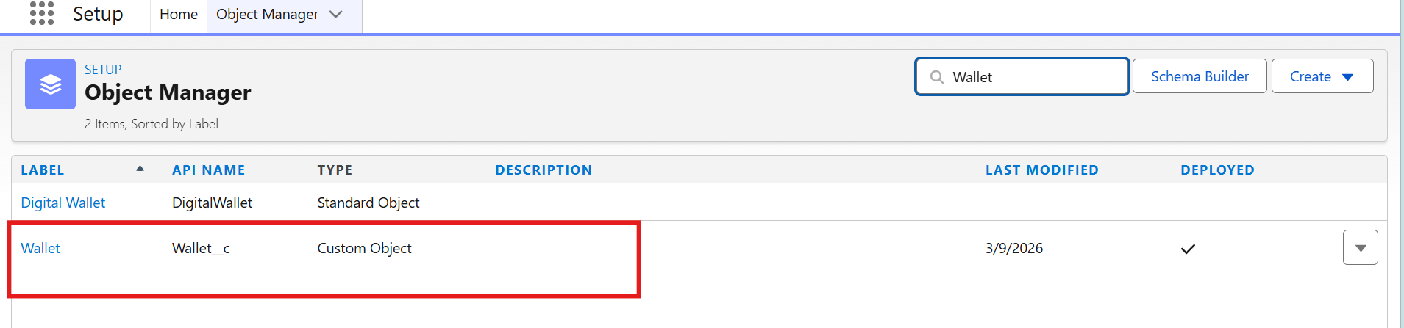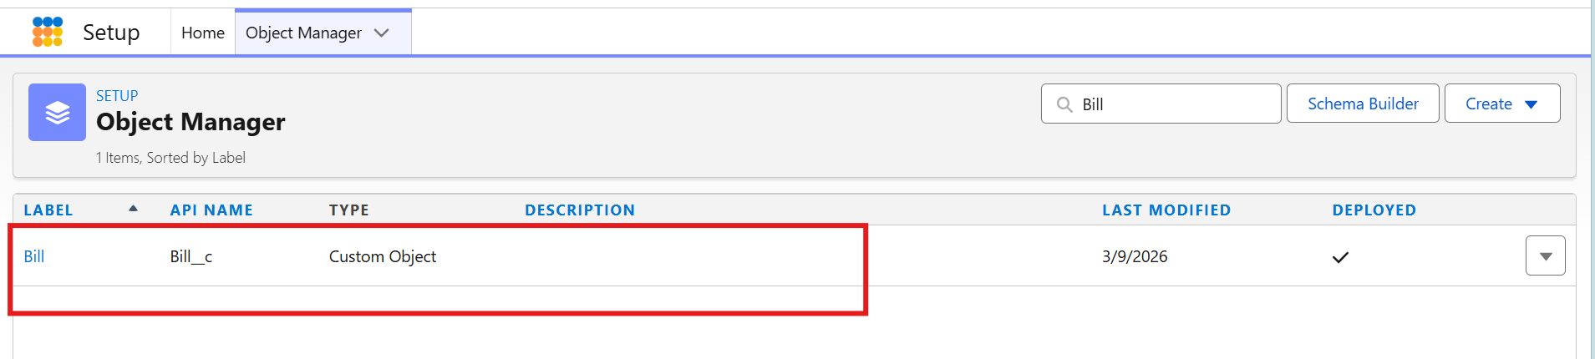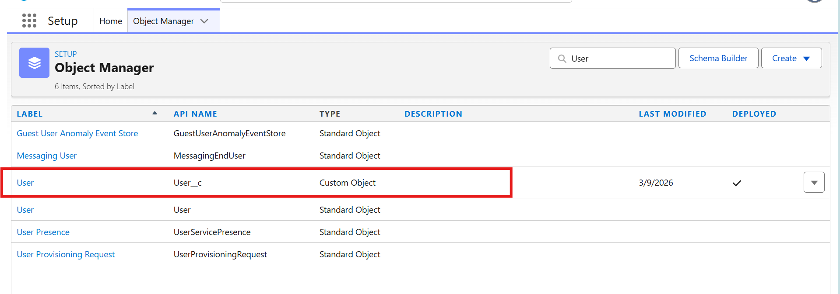
2. User object should have master detail relationship with both objects
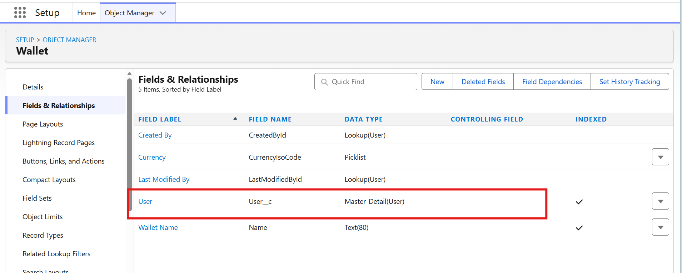

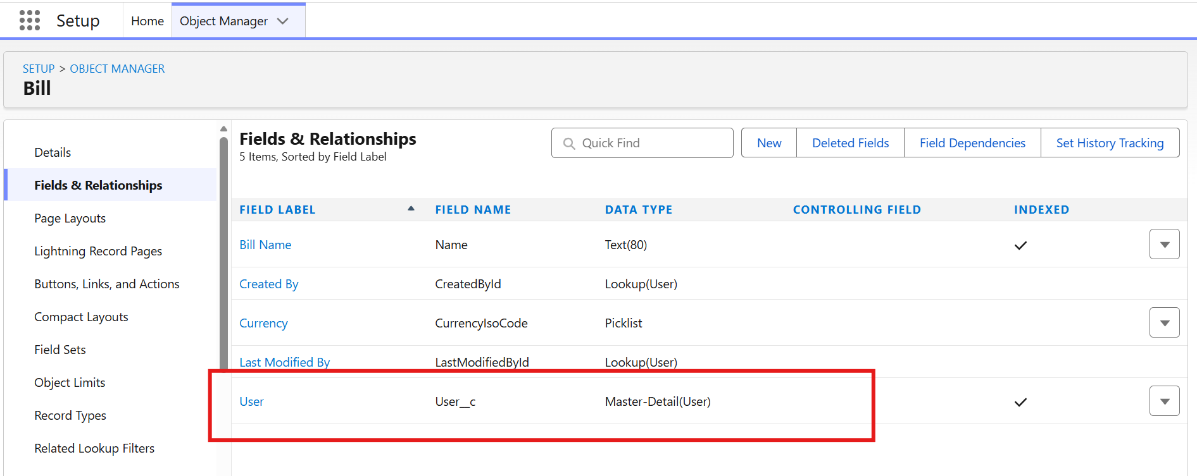

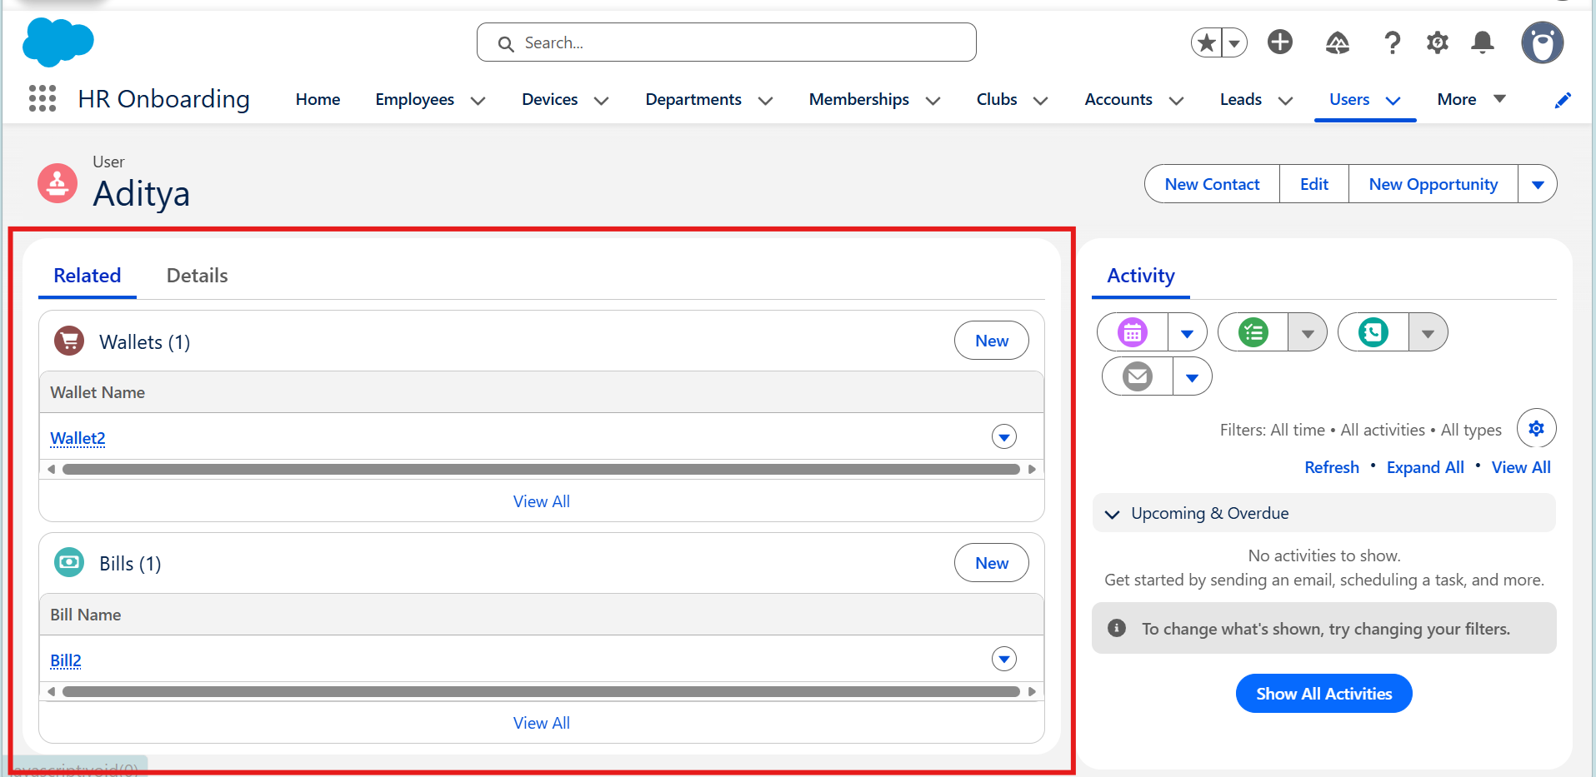

3. Wallet should have look up relationship with bill object
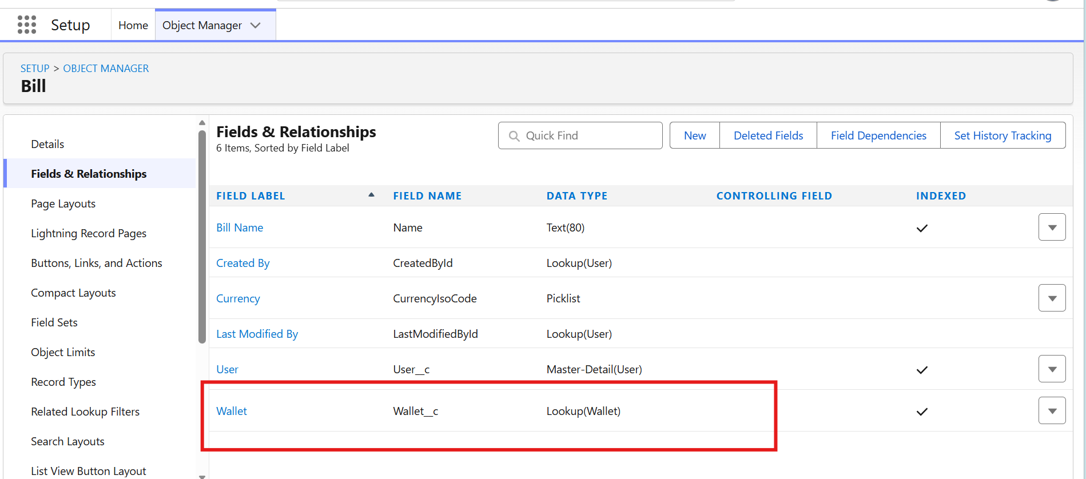
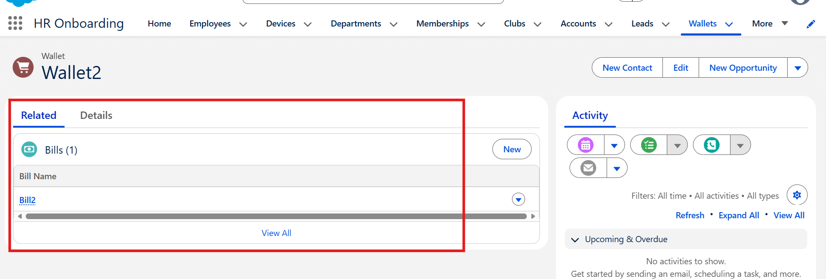

4. Bill object should have preferred method of payment field which is a picklist which should have following options: card, cash, upi arranged alphabetically
